For in loop

Workshop #4

Flutter Developer Bootcamp

# **Purpose**

This workshop demonstrates how to dynamically populate a list (items) with integers from 0 to 5 using a for loop, and then iterate over the elements of the list using a for-in loop to print each element to the console.

**Problem**

In the given workshop initializes an empty list items and fills it with integers from 0 to 3 using a for loop. Each integer is added to the list using items.add(i). Then, a for-in loop iterates over items and prints each integer to the console. This demonstrates basic list manipulation and looping in Dart, illustrating how to populate lists and iterate over their elements for output. You need to print integers from 0 to 5 sequentially.

**How to Solve**

1. Checkout the workshop from Git Repo:

git clone -b <user-branch> <repo-URL>

1. Open the root folder inside VS Code
2. Open the root folder in terminal
3. Run the command dart run filename.dart
4. Initialize an empty list items of type List<int>.
5. Use a for loop to iterate from 0 to 5.
6. Add each integer i to the items list using items.add(i).
7. Iterate over the items list using a for-in loop.
8. Print each integer item to the console during each iteration.
9. Go To File: <specific-file--method> à <method-name>, implement your logic.

**You will Achieve**

When you complete this workshop you will learn the following:

**Methods and Functions Used:**

* **main() Function:**
* Entry point of the Dart program where execution begins.
* Controls the flow of the program, including variable initialization, loop execution, and output handling.
* **List.add() Method:**
* Adds elements to the end of the items list dynamically during each iteration of the for loop.
* **For Loop:**
* Initiates a loop that iterates a specific number of times (6 iterations from 0 to 5).
* Handles index-based iteration and list population.
* **For-in Loop:**
* Iterates over each element in the items list sequentially.
* Provides access to each element (item) for processing or output operations.
* **Print Function (print()):**
* Outputs the value of each integer (item) to the console during the for-in loop iteration.
* Essential for displaying program output and debugging purposes.

# **Screenshots**

## **Before implementation (without printing 5 numbers)**

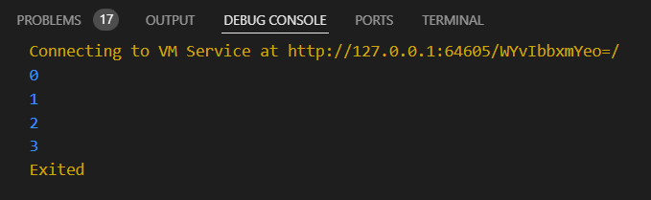

## **After implementation (with printing 5 numbers)**

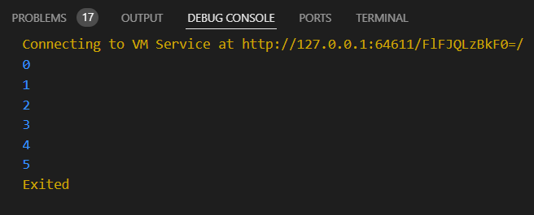

# **How to submit your workshop**

Push your project back to the same git branch using command:

<command name>

# **Happy Coding!**